
PAYMENT AUTHORIZATION FORM
Please Fax Your Completed Form To: 949-757-0375
For Payment By Credit Card:
Visa MasterCard AmEx Discover

Credit Card Number:

CCV: |  | Exp Date: |  |  | /

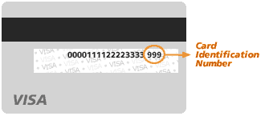
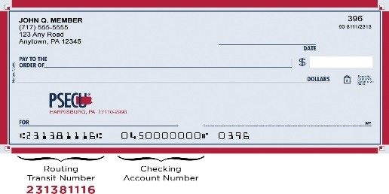
Credit Card charges will include a carrying charge of 3% of amount charged.

For Payment By Check (ACH):

Bank Name:
Bank City / State:

Account Type: Checking Account Savings Account

Bank Routing Number (9 digits):
Bank Account Number:

Insured’s Name:
Lawrence Ramstrum Construction

Insured’s Billing Address:
City: State: CA Zip:

Insured’s Phone Number: Insured’s Signature:
805-331-8100

I Authorize My Credit/Bank Card To Be Charged For The Below Amount by Roger Stone Insurance:
(Amount charged includes 3% charge for all credit card transactions) $1,250.96 + $37.53 Total $1,288.49

Amount Charged: $ | $1,288.49 | (USD) | Date:

Payment Options: Full Pay Monthly Bill Automatic Reoccurring

If you have any questions please contact our office at 949-757-0270
Roger Stone Insurance, 5015 Birch Street, Newport Beach CA 92660

